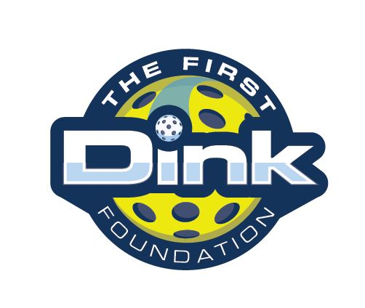

FIRST DINK

COACHING

HANDBOOK

[www.firstdink.org](http://www.firstdink.org)



**TABLE OF CONTENTS**

Welcome to First Dink

Core Values

Progression Levels

Coaching Philosophy

4 Building Blocks

6 C’s of Positive Youth Development

Coaching Strategies

Coach/Volunteer Policies

Class Procedures



**Welcome to   
The First Dink Foundation**

**The First Dink Foundation Mission:**

The mission of the First Dink Foundation is to “Serve Up Success” by empowering youth to reach their full potential and positively impact society. We use the sport of pickleball to instill crucial life skills, foster personal growth, and develop well-rounded citizens. Our programs build  
character, leadership, teamwork, and sportsmanship in kids and teens. We provide a supportive community that models integrity, hard work, and commitment on and off the court. Through mentorship and coaching, we prepare participants to meet life's challenges and opportunities. Our goal is to equip youth with the values, resilience, and sense of purpose to become engaged members of their communities who lead with character. By developing citizens first and athletes second, the First Dink Foundation aims to serve youth, families, and society at large.

**The First Dink Foundation:**

The First Dink Foundation is a non-profit organization dedicated to helping youth develop into upstanding citizens and future leaders through the sport of pickleball. Our programs use pickleball not just to teach athletic skills, but also as a platform for instilling crucial life lessons and building character. Through small-group lessons and mentorship from experienced coaches and volunteers, kids improve confidence and leadership abilities. They learn how to win and lose graciously, resolve conflicts, and work together toward shared objectives.

**The First Dink Foundation Five Core Values:**

**1. Teamwork**

**2. Respect**

**3. Leadership**

**4. Camaraderie**

**5. Empowerment**

**Teamwork**

We believe in the power of collaboration. Working together, supporting each other, and being good teammates are keys to our success on and off the court.

**Respect**

We respect ourselves, our teammates, our opponents, and the game. Good sportsmanship, manners, and fair play are always expected.

**Leadership**

We empower youth to lead by example. We teach the importance of responsibility, integrity, and serving as role models in the community.

**Camaraderie**

We build meaningful connections through shared interests and common goals. The friendships and community we create on the court stay with us for life.

**Empowerment**

We provide opportunities for youth to gain confidence, skills, and leadership capabilities. Our programs empower young people to achieve their full potential.



**The First Dink Foundation Acknowledgments**

The First Dink curriculum was designed in coordination with various groups and experts in the Positive Youth Development and Physical Education Fields.

We recognize and appreciate the following:

**Sam Veal**, Executive Director

**Mike Gainer**, Board of Directors

**Bradley Ernst**, Board of Directors

**Molly Alleger**, Board of Directors

**Loren Gay**, Board of Directors

**Leslie Godwin**, Director of Programing

**Mike Yarbrough**, Head Coach

**USA Pickleball Sportsmanship Guide**

[**Key Principles of Positive Youth Development | Youth.gov**](https://youth.gov/youth-topics/key-principles-positive-youth-development)

<https://youth.gov/youth-topics/key-principles-positive-youth-development>

**The First Tee** <https://firsttee.org>



**The First Dink Level Progression**

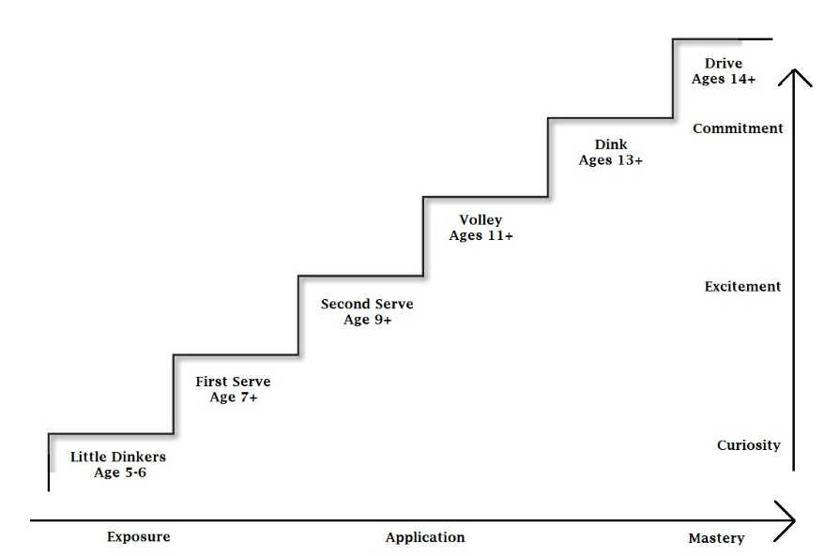

**Program Levels**

For many of our participants, The First Dink program will be a new experience. In addition to meeting other young people from different backgrounds, they will be exposed to pickleball in a fun environment that emphasizes courtesy & respect.

**LITTLE DINKERS Ages 5+** Creating Curiosity and Excitement by introducing the basics of Pickleball and being physically active. Participants will learn Life Skills: Showing Kindness to Others, The Importance of Sharing, & Taking turns. Pickleball Skills include: Stance on the Court, Holding a paddle, & Making contact with ball.

**FIRST SERVE Ages 7+** Introduce participants to the basics of pickleball and learn The First Dink Foundation’s Code of Conduct & Core Values. Participants will also learn basic Pickleball Skills: Serving the ball, Ball contact, Direction control, & Getting over the net.

**SECOND SERVE Ages 9**+ Maximize fun through games and exercises that reinforce the First Dink Core Values and the additional Life Skills: Interpersonal Skills, Self-Management, Communication, Teamwork, Responsibility, & Patience. Pickleball Skills include: Serves, Returns, 3rd Shot, Volley, Dinks, & Court Etiquette

**VOLLEY Ages 11+** How to set goals and accomplish them. Volley also addresses more advanced Pickleball techniques and Fundamentals of Practicing

**DINK Ages 13+** Situational scenarios to learn resilience, how to resolve conflict, and continue planning for the future. Pickleball training continues with increased practice by playing in tournament style sessions.

**DRIVE Ages 15**+ Putting all the Core Values and Life Skills Learned to the test on the court and in real life. Conversations are held about education, careers and how to give back to the community we live in.



**The First Dink Foundation**

**Coaching Philosophy, 4 Building Blocks,**

**6 C’s for Positive Youth Development**

Playing the game of Pickleball is great exposure for Young People. It is a fun game that provides clear rules and presents challenges on and off the court. The First Dink uses this environment to develop, empower, and instill Core Values in a youth friendly approach.

There are many ideas to help Positive Youth Development. The First Dink Foundation focuses in the following categories: The **External Influences,** and **Internal Motivation.**

**External Influences:** Adult mentors are crucial for modeling and supporting desired behaviors for positive youth development. Having certified and trained First Dink Coaches and Volunteers ensures our youth are creating safe, positive, and constructive relationships with others in addition to feeling included, and understanding our programs expectations.

**Internal Motivation:** Core Values are not automatic and take time to learn and become part of every day life. Internal motivation is nurtured over time, through repetitive experiences. While our youth will learn each of the core values definitions, through The First Dink Program, they will also learn how to apply and adapt to different scenarios and situations, ultimately having the core values integrate into their daily lives.

Overview: By itself, playing the game of pickleball is fun and healthy for our youth. But, by adding quality mentors and using the game as a learning environment for the Core Values, The First Dink ensures our youth’s lives are positively impacted.

The First Dink Coaching philosophy used the same **4 building blocks** as the First Tee, a golf youth development program. As Coaches increase their own awareness and effective use of these strategies and behaviors, coaches also increase the probability for creating optimal learning environments*

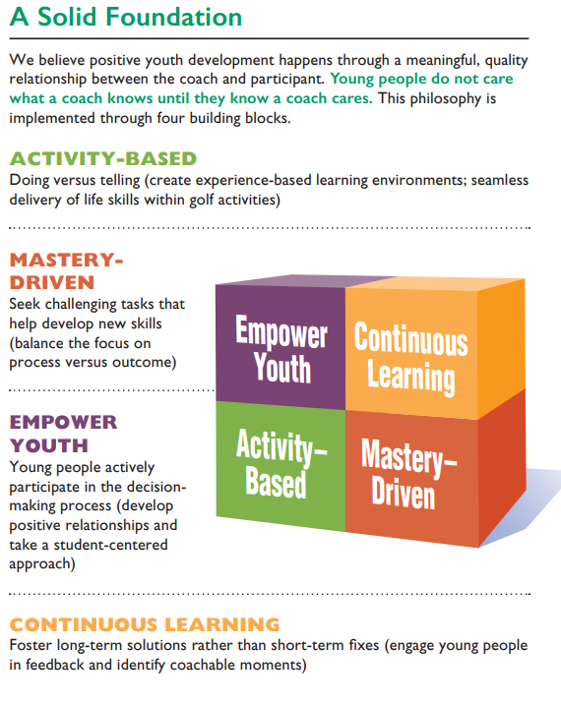

*firsttee.org

1. **Activity-Based**

**Doing vs. Telling**: use a hands-on approach whenever possible, and never lecture. Keep verbal instructions and monologues to a minimum, and during group discussion, engage everyone in the conversation.

**Fun and Seamless**: ensure that activities are designed as interactive games, where players spend more time engaged than disengaged, and there is very little waiting in line. Purposeful play allows participants to learn the lesson while being active.

1. **Mastery-Driven**

**Intention Equals Attention**: Make sure to model and reinforce the behaviors you want players to learn, and understand that any exception may undermine that message.

**Balancing Process and Outco**me: We will always be working on both process and outcome, and so it’s important to distinguish between and identify the two when working with young players. Often the focus should be shifted *away* from where the ball ends up and *toward* what the player is doing well in their technique.

1. **Empower Youth**

**Youth-centered**: Adults are responsible for designing and leading the class, but it is created for a youth audience, so it should be tailored to their age group and interests. More specifically, the players and their needs always come first.

**Relationship-focused**: The old adage “they don’t care what you know until they know that you care” is one of the most important to keep in mind. Get to know the player and their interests first, and then begin to help them with the lesson. You’ll both be more apt to learn.

1. **Continuous Learning**

**Coachable Moments**: Pickleball gives us the opportunity to learn many lessons, but we must acknowledge them to retain their full value. Likewise, moments will arise in class to learn from the game and from each other, and capturing these is a fun and vital coaching skill.

**Good-Better-How**: We do not measure things in terms of “good” vs. “bad.” Rather, we isolate what was good about the effort and then follow that with what could have been better, and how it could have been better. This is useful in any kind of review with players, other coaches and yourself, and the goods should always outnumber the betters.

**6 C’s for Positive Youth Development**

There are 5 core C’s :

*Competence*

*Connection*

*Confidence*

*Character*

*Caring*

*Contribution* is the Final C and describes the way in which youth who have successfully developed the first five C's give back to their community.

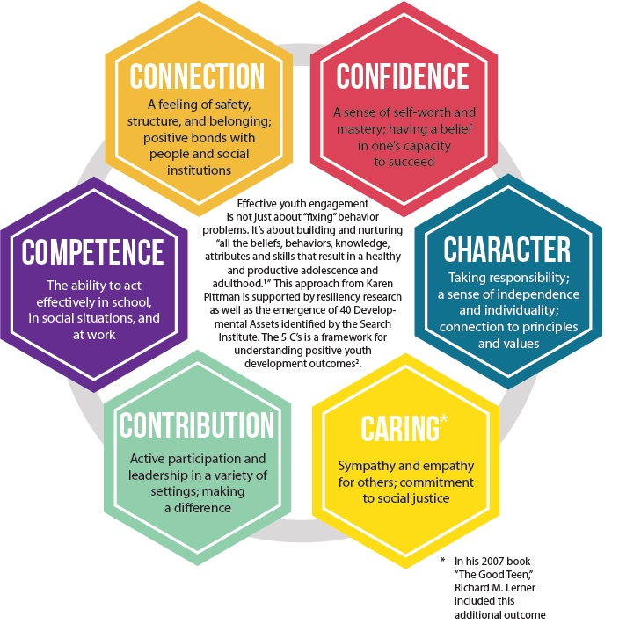

**Coaching Strategies for Optimized Learning**

For optimal learning and retention to take place, Coaches need to create age-appropriate, ability-appropriate, and time-appropriate environments.

Listed below are suggested strategies:

**Whole-Part-Whole**- Practice any pickleball skill as a “whole motion” before practicing any breakdown or specific move. You can focus on 1 specific skill until it is understood, but then shift focus back to the “whole motion”.

**Modeling**- Visuals benefit learning. When coaches model a skill, limit talking while demonstrating. If talking or explanation needs to occur, have one coach model while the other talks.

**Optimal Challenge**- Create activities with varying levels of challenge. Encourage youth to step beyond their current comfort zone and explore.

**Variable Practice**- change targets/ directions/ distances. Less skilled players need more practice with repetition before changing. More skilled players may switch more often.

**Providing feedback**- to promote confidence and interest, give more feedback after good motions/intentions. Give less feedback on bad shots or distractions.

**Focus on Attention**- give instruction and feedback that focuses youth attention on external/abstract ideas. This can help youth develop their own image and cross process ways of learning.   
Ex. “swing your arm like a circle”, or “move your balance towards the net”.

**10 Best Coaching Techniques**

**1. Be a role model** - While in the learning environment, be your best self.

**2. Be organized** - It is important to be organized, but understand there may be last minute changes. Keep your composure and reinforce players’ confidence in your leadership.

**3. Exude energy and enthusiasm** - Players should get the feeling that you want to be there.

**4. Be clear and concise** - When giving instructions or answering a question, be as articulate and brief as possible.

5**. Get on their level** - When you are youth-centered, the participants come first. Bend down or get on a knee when you speak with them, and participate in the games. They’ll appreciate your youthfulness and respect.

**6. Be patient** – Learning a new skill is challenging, and especially for young people whose physical attributes and motor skills are still in the developmental phase. Try to understand that they may be motivated by factors that are unbeknownst to you.

**7. Be positive** - Always focus on what was good about the attempt. There are no “bad” shots.

**8. Develop relationships** - Get to know everyone, and don’t be shy. Reach out and shake hands with coaches, players, & parents. Let them know who you are, why you’re there, and ask how you can help.

**9. Be task-oriented** - Model the behaviors you’d like to see, and players will follow your lead. Additionally, always maintain a fun, but task-oriented mentality. In other words, keep it lighthearted but focused.

**10. Demonstrate** - Don’t be afraid to grab a paddle or ball and try the shot yourself! Matching your attention to your intention, follow the same rules that you have set for the group. They’ll either be impressed with your talent or encouraged by the fact that you’re not perfect, but either way they will recognize that it must be a fun activity if you’re motivated to participate.



**The First Dink Foundation**

**Coach and Volunteer Policies**

**Dress Code**

Please dress in athletic attire appropriate for the weather. Please avoid denim, and if possible, sport a First Dink logo! Clothing that advertises beer, tobacco, illegal substances, violence and disrespect, or companies that manufacture or promote materials or goods that is inappropriate for children may not be worn during class.

**Language Policy**

While present in the learning environments, coaches and volunteers should always exercise good judgment when it comes to their choice of words, subject matter and dialogue. With the goal of creating a positive, family-friendly atmosphere, we strictly prohibit any foul language, cuss words, or inappropriate conversation. When in doubt, keep it G-rated.

**Substance Use Policy**

Smoking and drinking alcohol is not an acceptable behavior when in or around the First Dink environment. This means that consumption of these substances on the premises is strictly forbidden, and it is also requested that no trace of them be evident upon your arrival.

**Child Safety**

No coach or volunteer should ever be alone with a solitary student when away from the group activity. Please be mindful that there be another coach, volunteer, parent or adult present at all times when being around a solitary student. For bathroom breaks or individual attention of any kind, please ask for assistance from a member of the staff or other volunteers, or have participants find a “buddy.”

**Background Checks**

First Dink may conduct background checks on adults who interface with children. We appreciate your compliance with this policy in protection of the young people we serve, and if you have an outstanding circumstance we should be aware of, please contact us ASAP.



**The First Dink Foundation**

**Class Procedures**

**Lesson Planning**

Each week we introduce a new Core Value and set of skills, with planned Pickleball activities as the context. You will have the opportunity to review this material prior to the start of class. The role of staff coaches is to design and implement activities where players can practice and explore lessons as a group. Feel free to provide relevant input and ideas at the appropriate times, which is typically before or after class, or during transition.

**Typical Class Agenda**

* Pre-class Preparations:
  + Facility space is reserved
  + Equipment and activities are set up
  + Logistics discussed and finalized (timing, direction, sequence)
  + Coach /Volunteer meeting prior to participant arrivals
* Welcome and Introductions:
  + Meeting and greeting, students sign in on the class roster
  + Students obtain necessary equipment/materials
  + Final touches made on activities
  + Develop student and parent relationships
* Activity Delivery:
  + Warm-up & icebreaker activities
  + Review Core Lesson
  + Assign groups and stations, give clear directions
* Wrap-up and Conclusion:
  + Conclude games for the day, put away equipment
  + Review the day’s lesson, “guiding questions”
  + Hand out any homework
  + Ensure all students have safe transportation home

**Coach/Volunteer Arrival**

Please arrive no later than 30 minutes prior to the start of your class. Volunteers, please sign in on the class roster or volunteer sign-in sheet so we have a record of your attendance, and then be ready to get involved right away. The time just prior to class is crucial for setup and preparation, so consult a staff coach because your help may be needed with a specific task. If no assignment is given, request a briefing on the lesson plan and then simply make an effort to greet and direct families as they arrive for class.

**Coach/ Volunteer Cancellations**

If for any reason you will be unable to attend a scheduled class, please notify the Head Coach with as much notice as possible. We understand that emergencies occur in which communication may be limited, but we ask that you make your best effort. You will be provided with contact information for the Head Coach, and you are welcome to communicate with the Program Director and/or Volunteer Director anytime as well, who will communicate with your coaching team in a timely manner.

**Cancelation Policy & Make-Up Classes**

Missed classes by participants cannot be made up at this time. First Dink guarantees to provide 75% of sessions. If more than 25% of classes are cancelled (due to weather, closures, emergencies etc) and there is not an option to make-up, a “class credit” will be available for the participant to use in future registrations.

**Inclement Weather**

Classes are not cancelled for light rain. If possible, we will move indoors and continue the class. Parents and participants will be contacted an hour prior to classes starting if extenuating circumstances present (lightning in the area, thunderstorms, hurricanes, etc. )

**Permission to Leave the Premises**

ALL participants are expected to remain on pickleball court and with coaches or volunteers at all times. If parents would like to give participants’ permission to leave with other parents, please speak directly to lead coach to arrange.

**Student Misbehavior**

If a student is misbehaving, please ask the lead instructor how it should be addressed. Participants should always be communicated with respectfully and with empathy, so seek to understand their situation first. Rarely will you need to move beyond step 3, but at that point a Staff Coach should be involved.

* 1st Time – Verbal Warning
* 2nd Time – 5 minutes of “time out”
* 3rd Time – Time-out for the remainder of class and possible contact with parent/guardian
* 4th Time – Parent/guardian contact and possible suspension from the program

**Parent Involvement**

Parents are encouraged to get involved in the following ways:

* Reinforcing core values and life skills at home
* Encouraging students to practice
* Becoming a trained Volunteer

**Parents Attending Class**

Parents sometimes get over enthusiastic and want to become involved with their own children during the class. Although well intentioned, this may disrupt the class and makes many students feel uncomfortable, which can detract from the learning process. Parents are asked to observe at a distance, approved by Coach, and not distract or be involved with the student during class time.

|  |
| --- |
| **First Dink Coaching Handbook**  Signature of Compliance  “I, __________________________________ (please print your name), have read and understood the First Dink Foundation’s Coaching Handbook as approved by the First Dink Staff. I will comply with all policies and look forward to coaching!”  Signed ___________________________________  Date ____________________________________ |